PROJECT REPORT

**HOSPITAL MANAGEMENT SYSTEM**

BADRI ADUSUMALLI

**TABLE OF CONTENTS**

1. **Introduction**
2. **Objective**
3. **Scope Definition**
4. **Business Overview**
5. **Implementation & Evaluation**
6. **ER Diagram**
7. **Code and output Screenshots**
8. **Future Scope**
9. **Conclusion**
10. **References**
11. **Introduction**

* During the global pandemic around this world, we all realized how important healthcare is to everyone, and so is the healthcare management system.
* To make the healthcare sector more efficient and better in terms of technology, I have proposed creating my version of the hospital management database system.
* Hospital Management systems help to keep track of patients, staff, and doctors and even with the help of advanced querying logic that I have come up with, it makes it so much fun along with providing some interesting knowledge from the raw data.

1. **Objective**

* Our present modern information system makes use of computers for the execution, each of them connected through an optimized network.
* Healthcare is the most critical aspect of our society, and many healthcare providers face challenges in offering practical and active services to patients.
* Considering a multi-specialty hospital, many people enter and exit the hospital in a day and maintaining their records safely can result in a tedious process.
* To reduce this type of burden and to manage the financial, hospital administration and clinical aspects, the Hospital management system came into existence.
* This project aims to build a system to keep track of all data related to patients, employees (Ex: Nurses, Ward boys, Cleaners, Clerks etc.), medicines, and so much more.
* The database system will help the hospital to monitor all transactions (physical and/or digital) and help them in making informed decisions that are aligned with the company’s vision.

1. **Scope Definition**

* This database management system will be used to manage and maintain the records in a hospital.
* I aim at delivering a fully working Database Management where the data can be stored efficiently and evaluate insightful decisions with the help of triggers, stored procedures and functions.
* I have aimed at dividing our project into 3 modules-

Patient, Employee and Stock Management systems, respectively.

* Each module consists of corresponding tables accordingly.
* I aim to make the ease for patients as well as the hospital staff with the help of our database management system.

1. **Business Overview**

A hospital management system is a computer system that helps manage the information related to health care and aids in the job completion of healthcare providers effectively.

HMS came into the picture of hospital management as early as 1960 and had ever since been evolving and synchronizing with the technologies while modernizing healthcare facilities. In today’s world, the management of healthcare starts from the hands of the patients through their mobile phones and facilitates the patient's needs.

HMS was introduced to solve the complications coming from managing all the paperwork of every patient associated with the various departments of hospitalization with confidentiality. HMS provides the ability to manage all the paperwork in one place, reducing the work of staff in arranging and analyzing the patients' paperwork. HMS can help in many areas like

* Maintain the medical records of the patient
* Maintain the contact details of the patient
* Keeping track of the appointment dates
* Save the insurance information for later reference
* Tracking the bill payments.
* Maintain a proper flow of all the details involved with an HMS

1. **Implementation & Evaluation**

|  |  |
| --- | --- |
| Week 1 | Team Meeting and Ideation |
| Week 2 | Topic Finalization |
| Week 3 | Implementation and dividing tasks |
| Week 4 | Creating Tables |
| Week 5 | Insertion of Data |
| Week 6 | Finalizing Stored Procedures, Triggers , Views and Functions . |
| Week 7 | Queries |
| Week 8 | Implementation of Stored procedures and Functions |
| Week 9 | Implementation of Triggers and Views |
| Week 10 | Code Testing |
| Week 11 | Final Presentation and Report |

1. **ER Diagram**

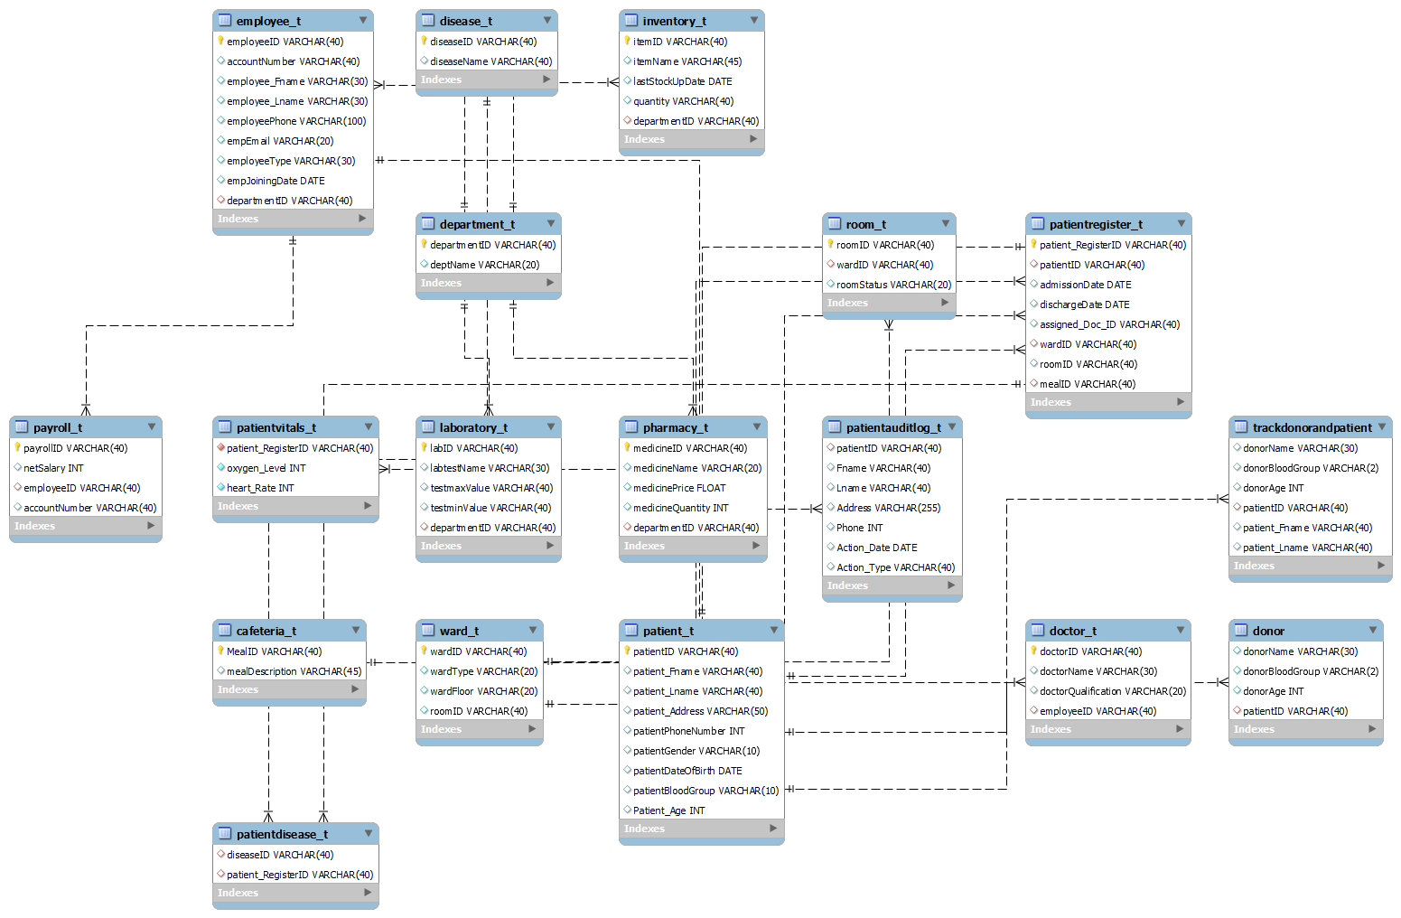

1. **Code and output Screenshots**

* **Stored Procedures**

#1 To find the diseases whose occurrence rate is high

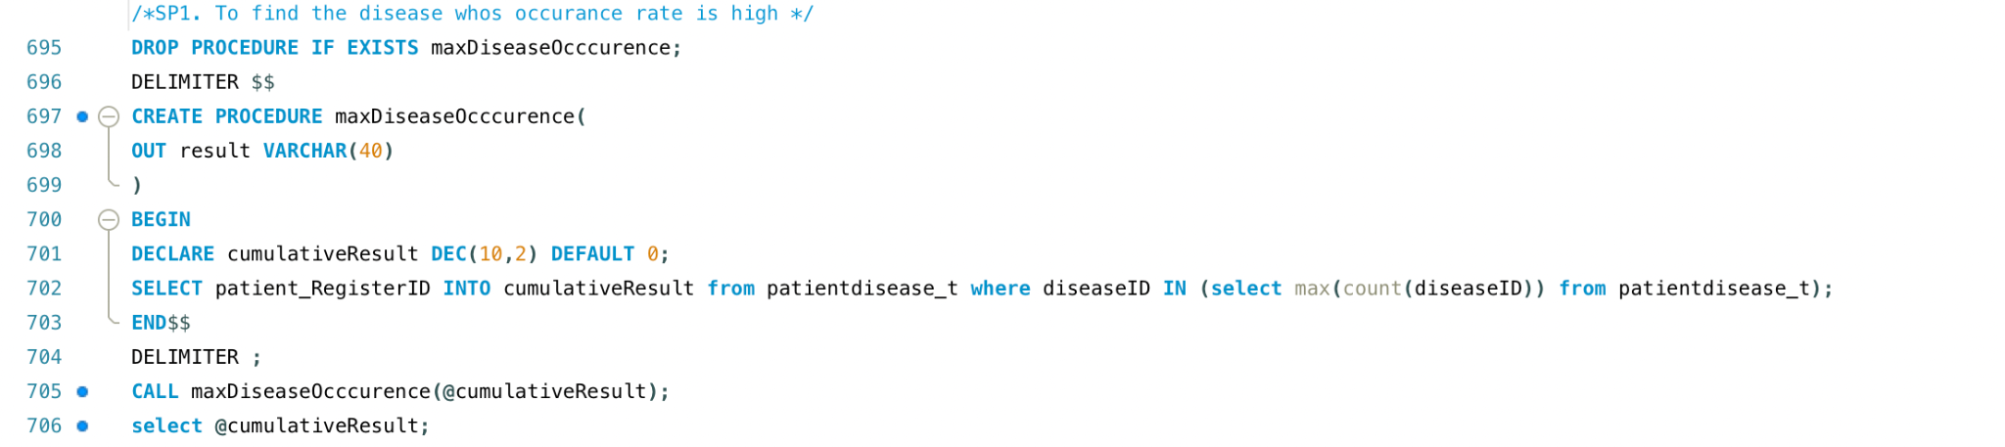

#2 Finding the name of the employees whose salary is greater than a specified range

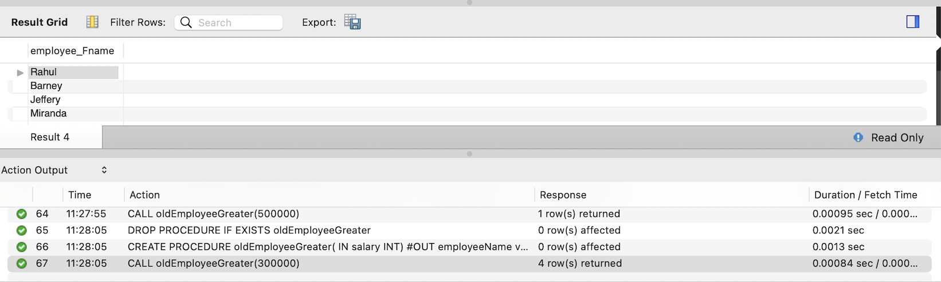

#3 To give bonus to employees whose tenure is greater than 10 years

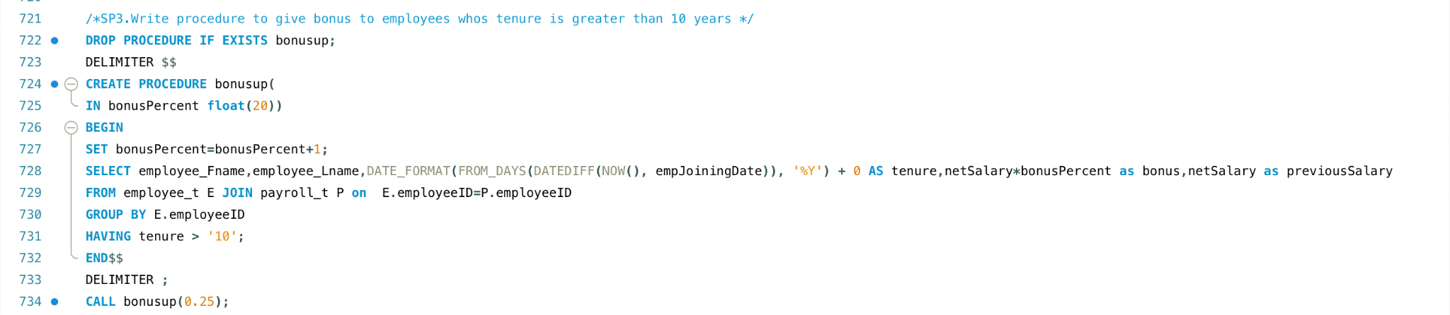

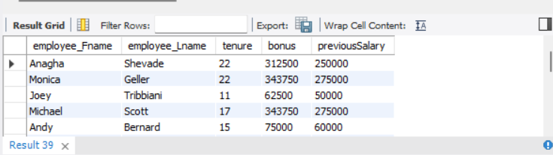

#4 To check the current room status

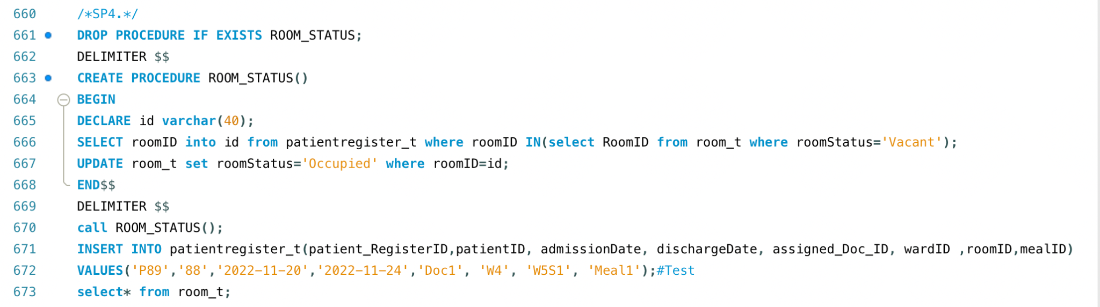

Before calling procedure

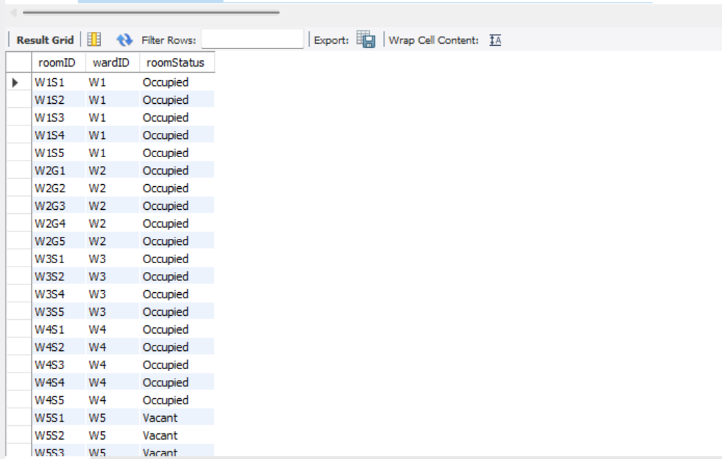

After calling Procedure

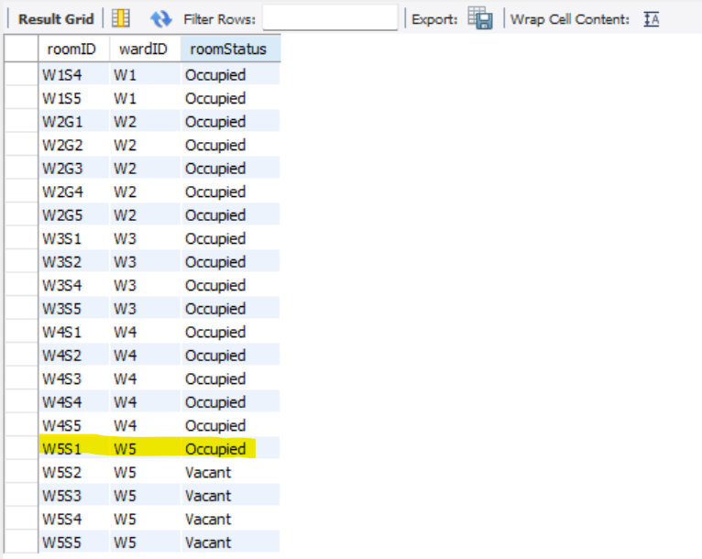

* **Triggers**

#1 Trigger to Check if Medicine quantity is less than 1000

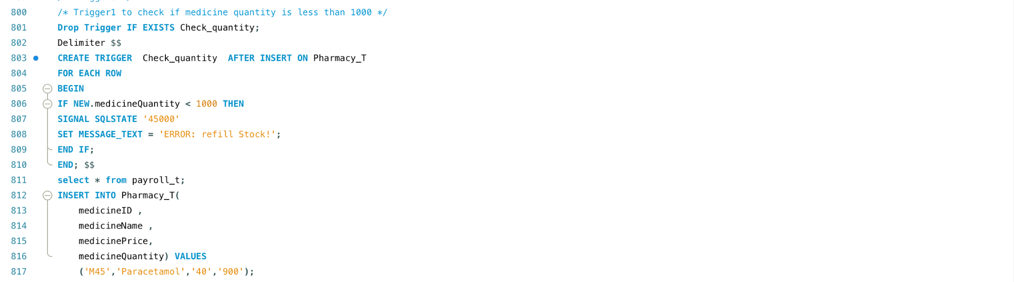



#2 Trigger to check after insert on donor data patient record is updated in trackdonorpatient table

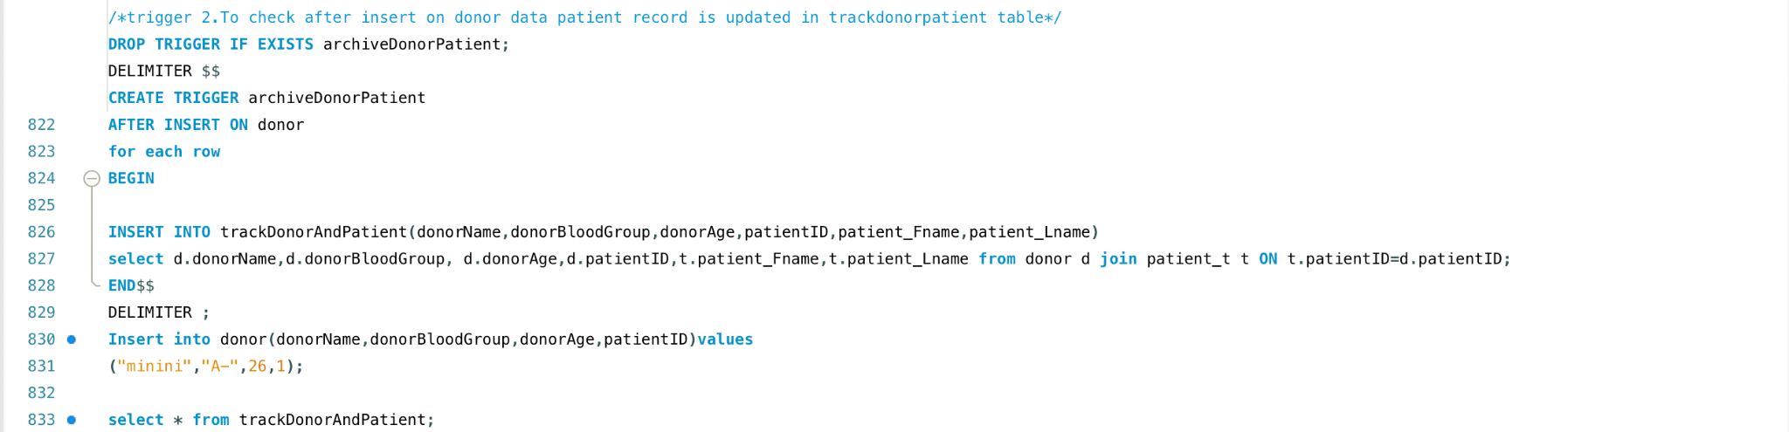

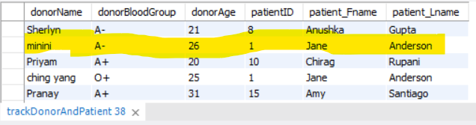

#3 Trigger to Monitor Patient's Oxygen level. If the oxygen level goes below 80, it should send a trigger and call the doctor.

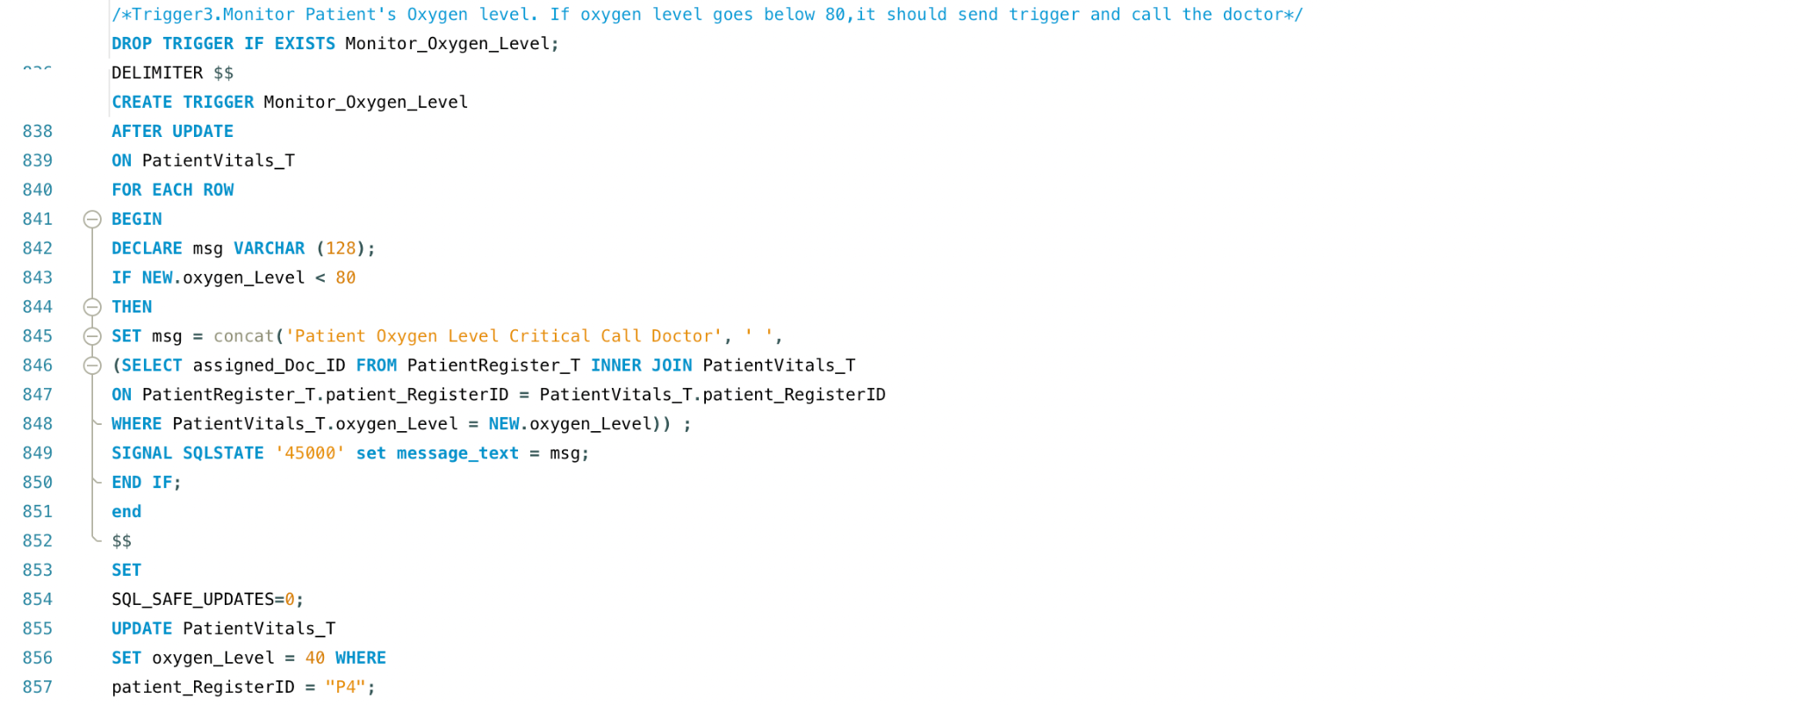



#4 Trigger to check whether the patient's heart rate goes above 110 or below 50 then trigger will run and send the msg check on the patient.

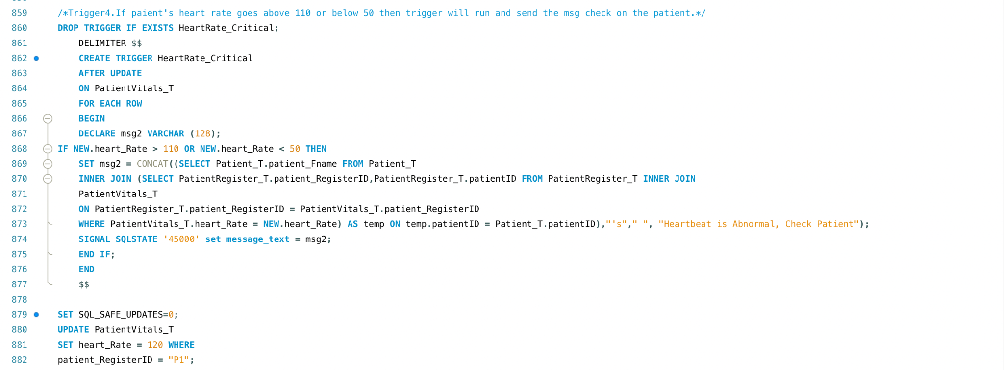



* **Views**

#1 Patient Ordinary Data

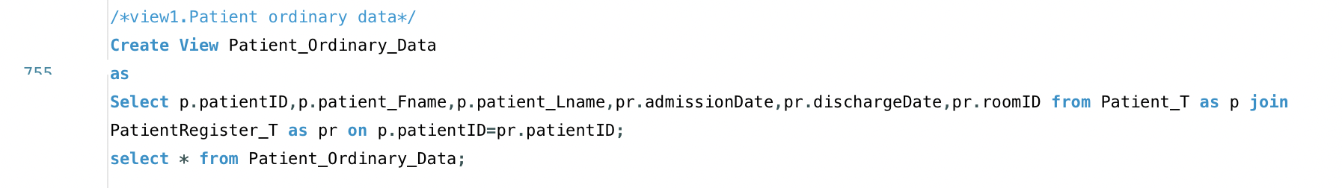

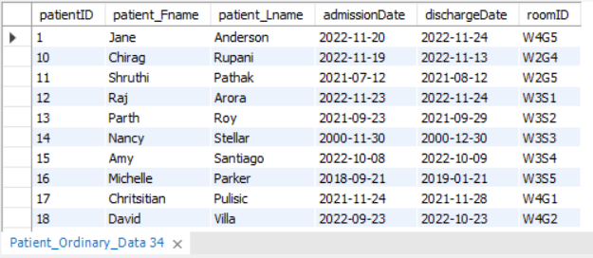

#2 Patient Sensitive Data

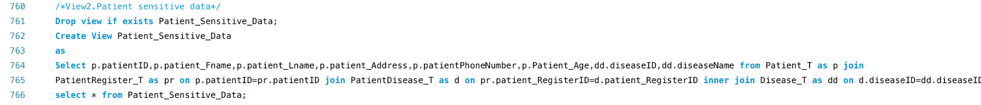



#3 Employee Sensitive Data

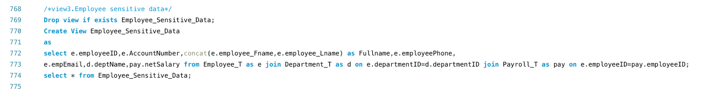

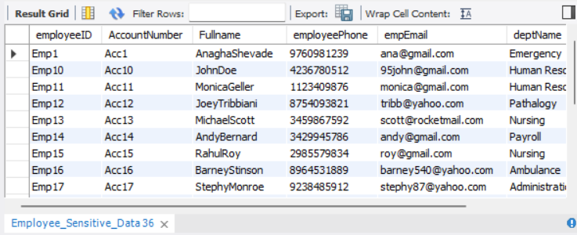

1. **Future Scope**

* This project can be further enhanced to link the real-time ID such as SSN or Insurance details that can retrieve the patient’s previous health records.
* We can use these records and store them in our archive so that we can write some meaningful Stored Procedures and Join operations to create some insightful decisions.
* An Ambulance management network can be linked with our project to track and improve the progress of-
* The ambulance reaching the patient + the ambulance bringing the patient to the hospital.
* Along with managing the drivers(staff), equipment in the ambulance (stocking) and a basic doctor/nurse to provide emergency CPR to the patient.
* We can also create and integrate a feedback system for patients to lodge their complaints and listen to their suggested potential improvements.

1. **Conclusion**

* Hence, I have created database management for the effective management of the hospital.
* Our Database contributes to the smooth workflow of operations by-

1. Storing the patient’s past and current data.
2. Enrolling and assigning new patients.
3. Maintaining and stocking the pharmacy as and when needed.
4. Keeping a track of the patient’s meals and room/ward.
5. Ensuring the Doctor’s data is stored separately and is linked to the patient assigned.
6. Support the employee records via the department.
7. Generate salaries and other finance using payroll definition.
8. Maintain the pathology records with the help of patient vitals.
9. Track dangerous and widespread diseases.
10. Track the blood donor and patients.
11. **References**

<https://ehealth4everyone.com/relevance-of-database-management-in-healthcare/>

<https://www.w3resource.com/sql-exercises/hospital-database-exercise/index.php>